Lets begin with very beginnign, what applications should be installed on my PC to be able to handle those requests. At the moment I have installed "PyCharm 2023.3.2 (Community Edition)" and anaconda navigator 2.6.2 What else should I install to be able to receive requests from Game server.

ChatGPT said:
ChatGPT
Memory updated
To set up your environment for receiving and handling requests from the game server, you'll need to install and configure the following tools in addition to what you already have (PyCharm and Anaconda Navigator):

1. Python and Virtual Environment
- Ensure you have Python 3.x installed. You can check by running:
bash
Copy code
python --version
If not installed, download Python from python.org and install it.
- Create a virtual environment (this keeps your dependencies isolated):
bash
Copy code
python -m venv venv
Activate the virtual environment:
  - On Windows:
bash
Copy code
.\venv\Scripts\activate
  - On macOS/Linux:
bash
Copy code
source venv/bin/activate

2. Web Framework (FastAPI or Flask)
Install FastAPI for creating and handling API requests, along with Uvicorn for running the web server:
bash
Copy code
pip install fastapi uvicorn
Alternatively, if you prefer Flask:
bash
Copy code
pip install flask

3. Database (PostgreSQL or MySQL)
- You’ll need a database system like PostgreSQL or MySQL to store player and wallet data. Download and install:
  - PostgreSQL: postgresql.org
  - MySQL: mysql.com
- Install a PostgreSQL/MySQL client on your system:
bash
Copy code
pip install psycopg2-binary # for PostgreSQL
pip install mysqlclient # for MySQL

4. Postman or Insomnia (API Testing Tools)
- Install Postman or Insomnia to easily test your API endpoints. These tools will help you simulate requests from the game server.
  - Postman: postman.com
  - Insomnia: insomnia.rest

5. HTTPS Certificates (for Production)
- If you need to work in production with real servers, set up HTTPS certificates for secure communication. For local development, you can use self-signed certificates or tools like ngrok to expose your local server securely to the internet.

6. Database Management Tools
- You can use pgAdmin (for PostgreSQL) or MySQL Workbench to manage your database, create tables, and visualize data.
  - pgAdmin: pgadmin.org
  - MySQL Workbench: mysql.com

7. Git (Version Control)
- Install Git to keep track of your project versions and changes:
  - Git: git-scm.com

Summary of Installations:
- Python 3.x and virtual environment setup.
- FastAPI or Flask (web framework) with Uvicorn for FastAPI.
- PostgreSQL or MySQL database and database client.
- Postman or Insomnia for API testing.
- pgAdmin or MySQL Workbench for database management.
- Git for version control.
After installing these, you’ll be ready to handle requests and start building your wallet system. Let me know if you want further details on setting up any specific tool!

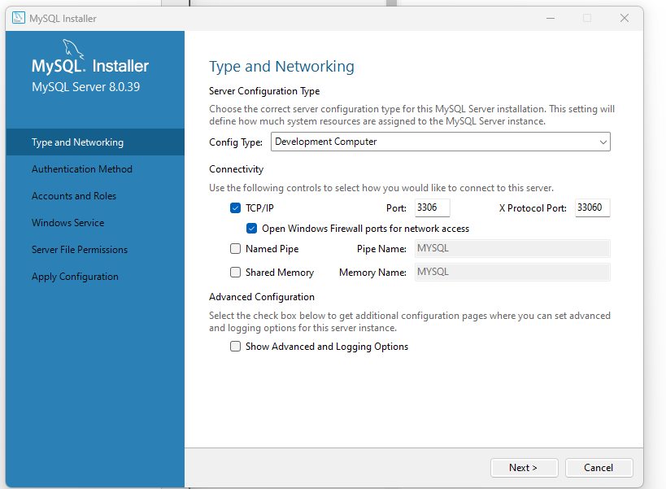

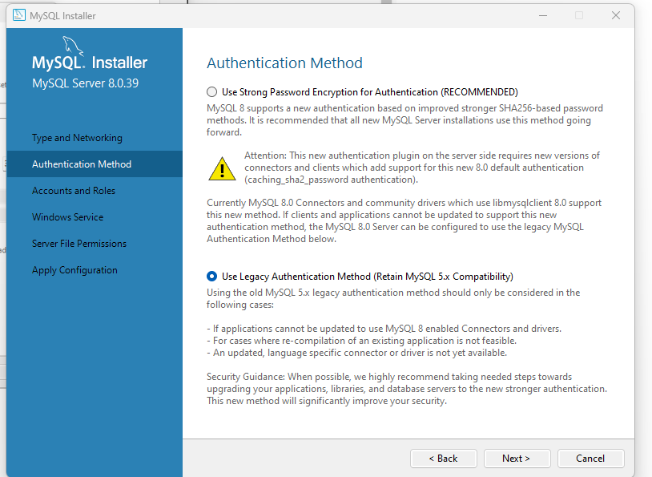

Root DB pass Moldova1981!
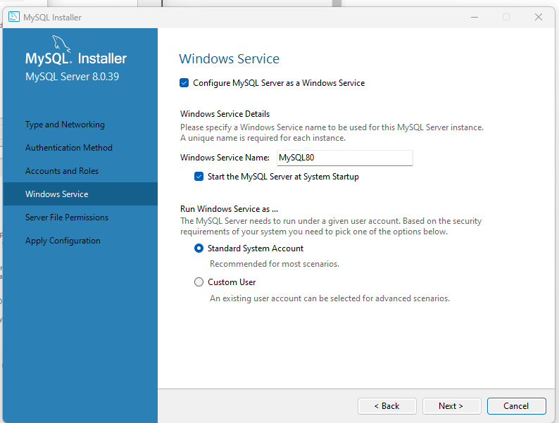

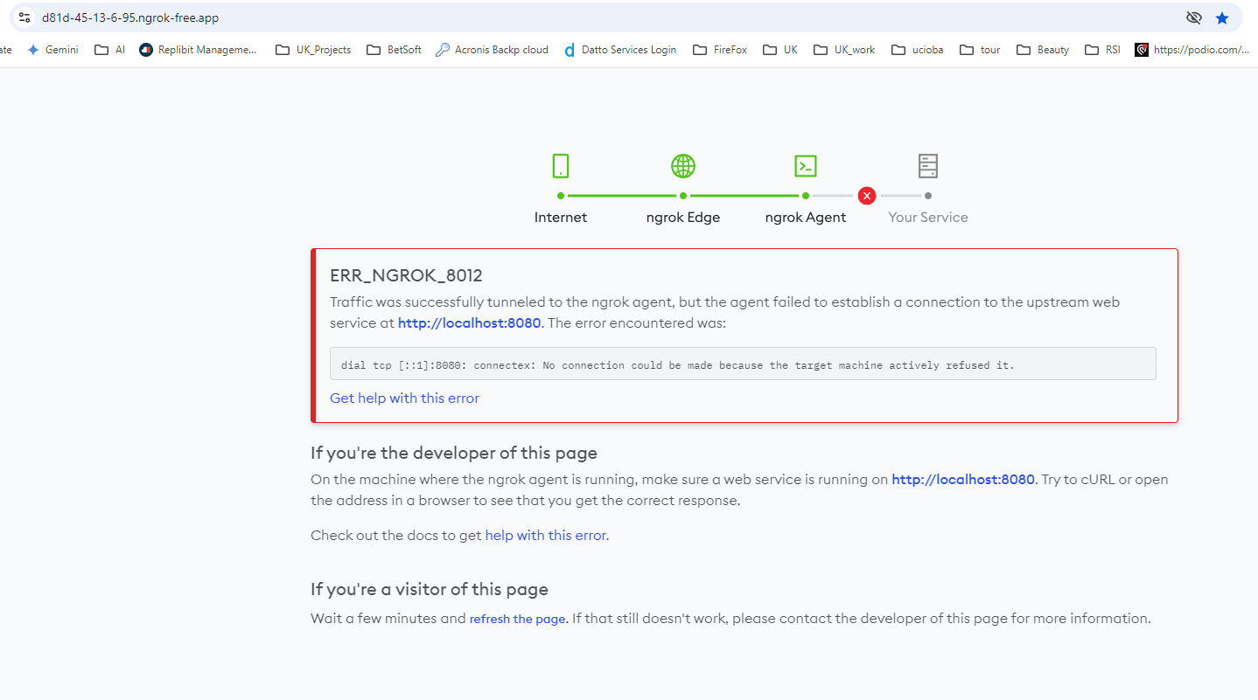

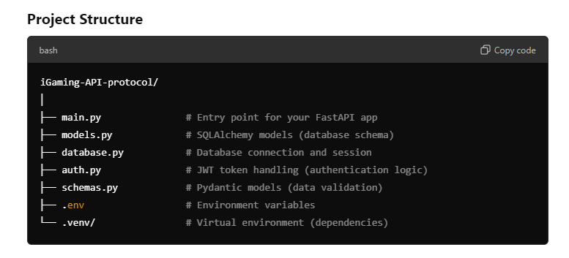

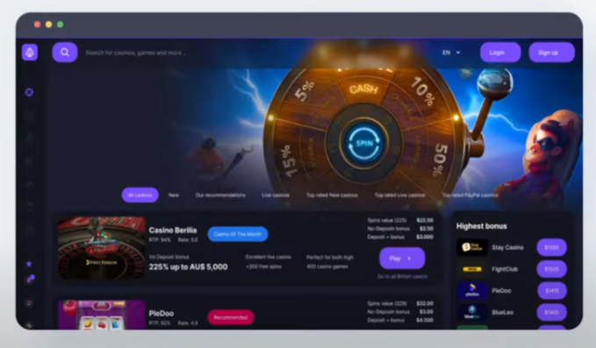
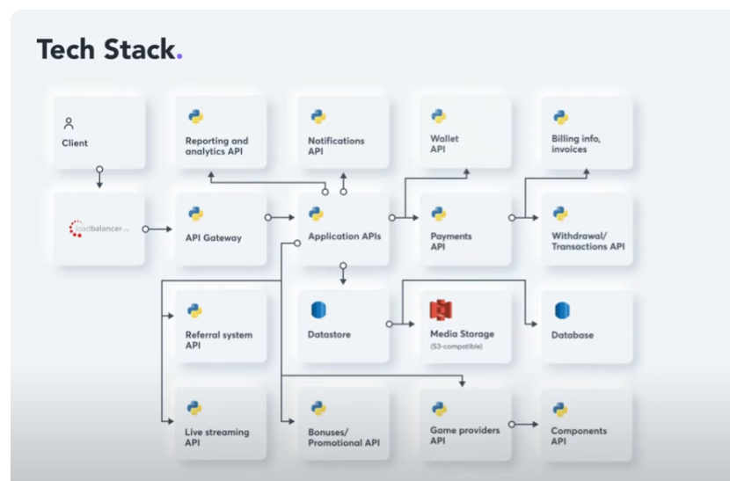

DB schema:
-- =======================
-- Players Table
-- Stores player information, including personal details and registration status.
-- =======================
CREATE TABLE players (
player_id INT PRIMARY KEY AUTO_INCREMENT, -- Unique identifier for each player.
first_name VARCHAR(100), -- Player's first name.
last_name VARCHAR(100), -- Player's last name.
email VARCHAR(255) UNIQUE NOT NULL, -- Player's email, must be unique and not null.
password_hash VARCHAR(255) NOT NULL, -- Hashed password for security purposes.
language_code CHAR(2) NOT NULL, -- Player's preferred language in ISO format (e.g., 'en', 'fr').
registration_date TIMESTAMP DEFAULT CURRENT_TIMESTAMP, -- Date and time of registration.
status ENUM('active', 'inactive', 'banned') DEFAULT 'active', -- Status of the account: active, inactive, or banned.
date_of_birth DATE, -- Player's date of birth.
phone_number VARCHAR(20), -- Optional phone number for contact.
country VARCHAR(100) -- Optional country of residence for localized content or restrictions.
);

-- =======================
-- Sessions Table
-- Tracks login sessions, tokens, and session times for players.
-- =======================
CREATE TABLE sessions (
session_id INT PRIMARY KEY AUTO_INCREMENT, -- Unique identifier for each session.
player_id INT NOT NULL, -- Foreign key referencing the player who initiated the session.
token VARCHAR(255) UNIQUE NOT NULL, -- Unique session token for authentication.
login_time TIMESTAMP DEFAULT CURRENT_TIMESTAMP, -- When the player logged in.
logout_time TIMESTAMP NULL, -- When the player logged out (null if still logged in).
FOREIGN KEY (player_id) REFERENCES players(player_id) -- Links the session to the player.
);

-- =======================
-- Wallets Table
-- Stores wallet information for each player, including different wallet types (FUN, REAL) and balances.
-- =======================
CREATE TABLE wallets (
wallet_id INT PRIMARY KEY AUTO_INCREMENT, -- Unique identifier for each wallet.
player_id INT NOT NULL, -- Foreign key linking the wallet to a player.
wallet_type ENUM('FUN', 'REAL') NOT NULL, -- Type of wallet: FUN for virtual credits, REAL for actual money.
balance DECIMAL(15, 2) DEFAULT 0.00, -- Balance of the wallet.
currency_code CHAR(3) NOT NULL DEFAULT 'USD', -- Currency code in ISO format (default 'USD').
last_updated TIMESTAMP DEFAULT CURRENT_TIMESTAMP ON UPDATE CURRENT_TIMESTAMP, -- Last time the balance was updated.
FOREIGN KEY (player_id) REFERENCES players(player_id), -- Links the wallet to the player.
UNIQUE(player_id, wallet_type) -- Ensures each player has only one wallet per type (FUN and REAL).
);

-- =======================
-- Free Round Bonus Table
-- Tracks bonuses (free rounds) given to players.
-- =======================
CREATE TABLE free_round_bonuses (
bonus_id INT PRIMARY KEY AUTO_INCREMENT, -- Unique identifier for each bonus.
player_id INT NOT NULL, -- Foreign key linking the bonus to a player.
granted_date TIMESTAMP DEFAULT CURRENT_TIMESTAMP, -- Date and time the bonus was granted.
rounds INT DEFAULT 0, -- Number of free rounds granted.
expiry_date TIMESTAMP NULL, -- Optional expiration date for the bonus.
FOREIGN KEY (player_id) REFERENCES players(player_id) -- Links the bonus to the player.
);

-- =======================
-- Gameplay Transactions Table
-- Tracks in-game transactions such as game wins and bets.
-- =======================
CREATE TABLE gameplay_transactions (
transaction_id INT PRIMARY KEY AUTO_INCREMENT, -- Unique identifier for each transaction.
wallet_id INT NOT NULL, -- Foreign key linking the transaction to a wallet (could be FUN or REAL).
transaction_type ENUM('gamewin', 'gamebet') NOT NULL, -- Type of transaction: gamewin (win), gamebet (bet).
amount DECIMAL(15, 2) NOT NULL, -- Amount involved in the transaction.
transaction_date TIMESTAMP DEFAULT CURRENT_TIMESTAMP, -- Date and time of the transaction.
description VARCHAR(255), -- Optional description of the transaction.
external_transaction_id VARCHAR(255), -- ID from an external service, if applicable.
FOREIGN KEY (wallet_id) REFERENCES wallets(wallet_id) -- Links the transaction to a wallet.
);

-- =======================
-- Deposit/Withdrawal Transactions Table
-- Handles deposits and withdrawals from REAL wallets, including status tracking for approval.
-- =======================
CREATE TABLE deposit_withdrawal_transactions (
transaction_id INT PRIMARY KEY AUTO_INCREMENT, -- Unique identifier for each transaction.
wallet_id INT NOT NULL, -- Foreign key linking the transaction to a REAL wallet.
transaction_type ENUM('deposit', 'withdrawal', 'bonus') NOT NULL, -- Type of transaction: deposit, withdrawal, or bonus.
amount DECIMAL(15, 2) NOT NULL, -- Amount involved in the transaction.
transaction_date TIMESTAMP DEFAULT CURRENT_TIMESTAMP, -- Date and time of the transaction.
description VARCHAR(255), -- Optional description of the transaction.
external_service_reference VARCHAR(255), -- Reference ID from the external API/service handling the transaction.
external_transaction_id VARCHAR(255), -- External transaction ID for traceability.
status ENUM('pending', 'approved', 'canceled') DEFAULT 'pending', -- Status of the transaction: pending, approved, or canceled.
FOREIGN KEY (wallet_id) REFERENCES wallets(wallet_id) -- Links the transaction to a REAL wallet.
);

-- =======================
-- Bonus Transactions Table
-- Tracks bonus-related transactions, such as credits or debits to wallets for bonuses.
-- =======================
CREATE TABLE bonus_transactions (
transaction_id INT PRIMARY KEY AUTO_INCREMENT, -- Unique identifier for each transaction.
wallet_id INT NOT NULL, -- Foreign key linking the transaction to a wallet (could be FUN or REAL).
transaction_type ENUM('bonus_credit', 'bonus_debit') NOT NULL, -- Type of transaction: credit or debit for a bonus.
amount DECIMAL(15, 2) NOT NULL, -- Amount involved in the transaction.
transaction_date TIMESTAMP DEFAULT CURRENT_TIMESTAMP, -- Date and time of the transaction.
description VARCHAR(255), -- Optional description of the transaction.
external_transaction_id VARCHAR(255), -- External transaction ID for traceability.
bonus_id INT, -- Reference to the bonus, if applicable.
FOREIGN KEY (wallet_id) REFERENCES wallets(wallet_id), -- Links the transaction to a wallet.
FOREIGN KEY (bonus_id) REFERENCES free_round_bonuses(bonus_id) -- Links the transaction to a bonus, if applicable.
);

-- =======================
-- Audit Logs Table
-- Records actions related to player accounts for security and transparency.
-- =======================
CREATE TABLE audit_logs (
log_id INT PRIMARY KEY AUTO_INCREMENT, -- Unique identifier for each log entry.
player_id INT, -- Foreign key linking the log entry to a player.
action VARCHAR(255) NOT NULL, -- Description of the action performed.
timestamp TIMESTAMP DEFAULT CURRENT_TIMESTAMP, -- When the action was performed.
ip_address VARCHAR(45), -- IP address of the user who performed the action (supports both IPv4 and IPv6).
FOREIGN KEY (player_id) REFERENCES players(player_id) -- Links the log entry to a player.
);

-- =======================
-- Trigger: Create Default Wallets
-- Automatically creates a FUN and a REAL wallet for a player when they register.
-- =======================
DELIMITER //
CREATE TRIGGER create_default_wallets AFTER INSERT ON players
FOR EACH ROW
BEGIN
-- Insert a FUN wallet for the player
INSERT INTO wallets (player_id, wallet_type, currency_code) VALUES (NEW.player_id, 'FUN', 'USD');
-- Insert a REAL wallet for the player
INSERT INTO wallets (player_id, wallet_type, currency_code) VALUES (NEW.player_id, 'REAL', 'USD');
END //
DELIMITER ;

Recommendations
Include the session's expiration time in the token, which you already have, and in the session record in the database. This will allow you to purge expired sessions easily.

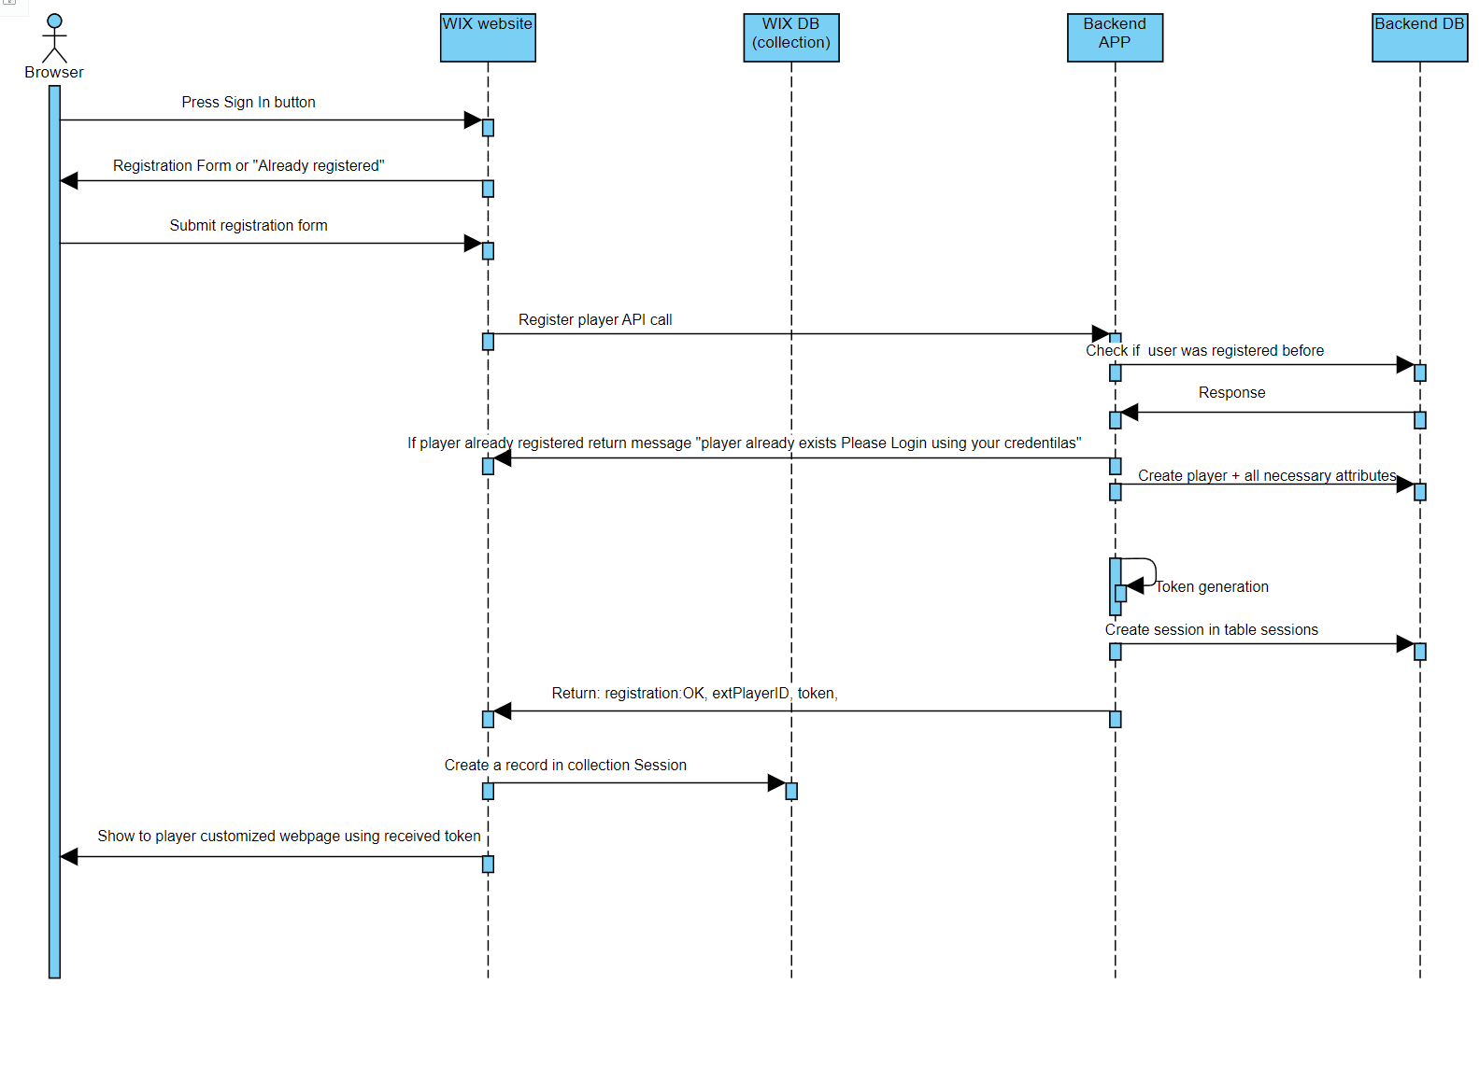

• Player Registration Endpoint
- Purpose: Registers a new player in the system, creates associated wallets, and returns an authentication token.
- Endpoint: POST /register-player
- Input: Player information (username, email, password, etc.)
- Output: Success message with player ID, token, and relevant data.
• Player Login Endpoint
- Purpose: Allows an existing player to log in and receive a token if the credentials are correct.
- Endpoint: POST /login
- Input: Player credentials (username, password)
- Output: Success message with a token and session-related information.
• Token Regeneration Endpoint
- Purpose: Regenerates a token if the player’s session needs to be extended.
- Endpoint: POST /refresh-token
- Input: Current token or player ID.
- Output: New token with an updated expiration time.
• Session Termination Endpoint
- Purpose: Terminates the player's session upon logout.
- Endpoint: POST /logout
- Input: Player ID or token.
- Output: Success message confirming session termination.

To be able to start the app in debug mode main file should start the server.

While starting from console this uvicorn main:app --reload --log-level debug it wont work from debug mode in pycharm

This code need to be added in the end of the main file

if __name__ == "__main__":
uvicorn.run(app, host="0.0.0.0", port=8000)

Here is the full worng main file

“import logging
import sys
import uvicorn
from routers import player
from fastapi import FastAPI
app = FastAPI()
# Configure logging
logging.basicConfig(level=logging.DEBUG)
logger = logging.getLogger(__name__)
app.include_router(player.router)
print("Main file was loaded")
@app.get("/")
async def root():
return {"message": "Welcome to the game backend!"}
if __name__ == "__main__":
uvicorn.run(app, host="0.0.0.0", port=8000)
”

